TASK 1 – Part 1:

For this exercise, we needed to crop the image of the shuttle from the original image. So we used simple slicing with the coordinates of the shuttle to clearly display the shuttle only and discard the rest

. 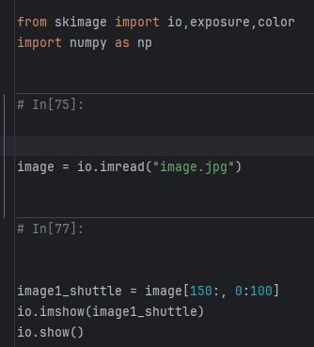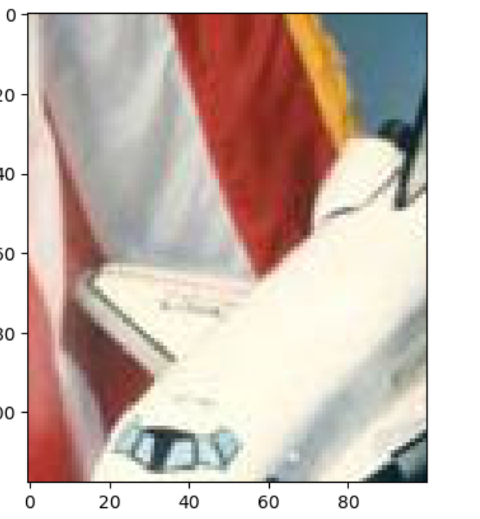

PART 2:

For this exercise, we first needed to take copies of the original image just for safety reasons, then take in the coordinates that will gives the image of the astronaut alone with the corresponding channel for each of the colours (Red, Green, Blue).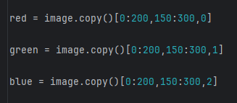

Red Grayscale Image:

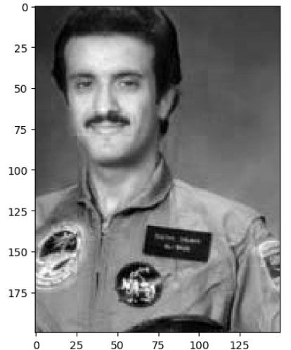

Green Grayscale Image:

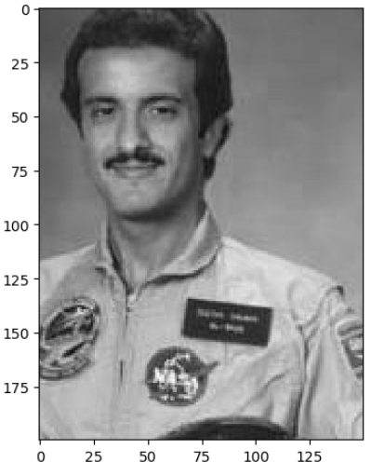

Blue Grayscale Image:

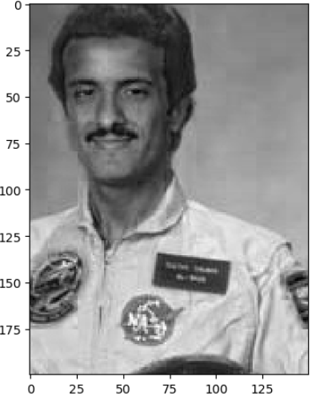

Part 3:

The red channel has a value of 0

Part 4:

The green channel has a value of 1

Part 5:

The blue channel has a value of 2

EXTRA CHALLENGE:

We set thresholds for the white and black, nested for loop to go through each pixel value in the image, then we extracted the RGB values for each pixel, then we tested the RGB values if above white threshold, we turn it to completely red. If below the black threshold, we turn it to completely blue.

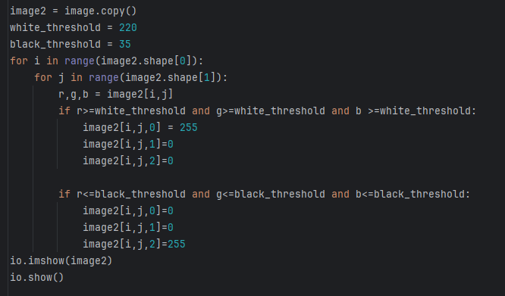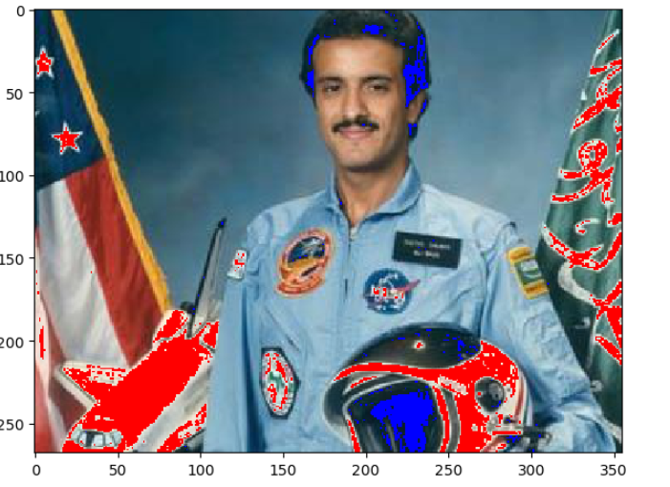

TASK 2:

We read the dog image, then set the value of gamma to whatever the user decides (in this case 0.1), then use adjust_gamma to power each value of rgb to the gamma value.

